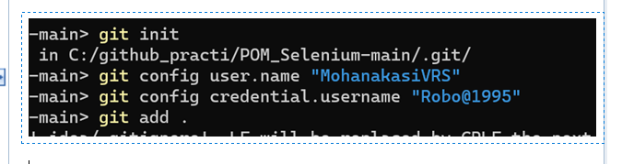

git init

git remote add origin "repo url"

git pull origin branch_name

git status

git add "file_name"

git commit -m "messege"

git push origin branch_name

git pull origin branch_name

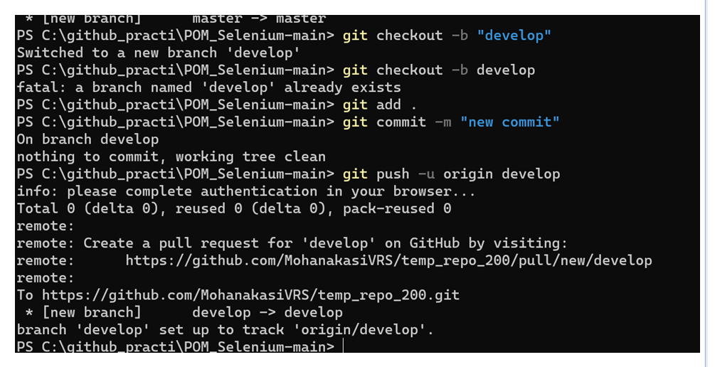

Another way of merging master & main

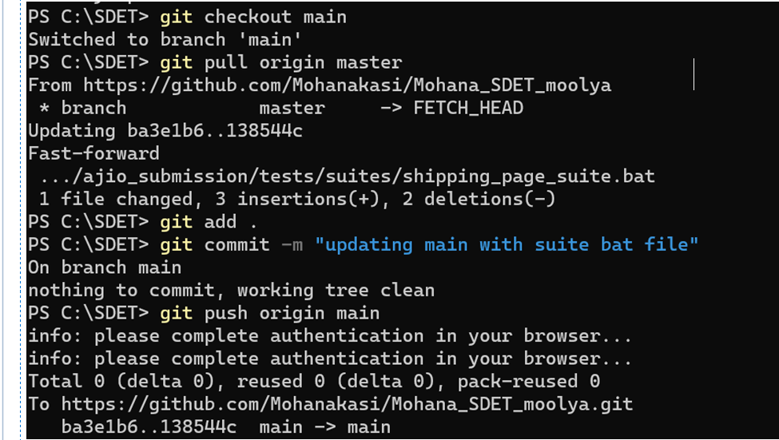

**One proper working of git operations(merging):**

C:\my_vs>

**PS C:\Demo> git checkout master**

Switched to branch 'master'

Your branch is up to date with 'origin/master'.

**PS C:\Demo> git pull**

Updating 00ec609..96f50ba

Fast-forward

Tests/trial1.robot | 2 +-

1 file changed, 1 insertion(+), 1 deletion(-)

PS C:\Demo> **git checkout develop**

Switched to branch 'develop'

**PS C:\Demo> git merge master**

Auto-merging Tests/trial1.robot

Merge made by the 'ort' strategy.

Tests/trial1.robot | 2 +-

1 file changed, 1 insertion(+), 1 deletion(-)

PS C:\Demo>

<https://github.com/MohanakasiVRS/vs_practice_repo.git>

Cloning into 'vs_practice_repo'...

remote: Enumerating objects: 21, done.

remote: Counting objects: 100% (21/21), done.

remote: Compressing objects: 100% (10/10), done.

remote: Total 21 (delta 1), reused 21 (delta 1), pack-reused 0

Receiving objects: 100% (21/21), 79.06 KiB | 1.23 MiB/s, done.

Resolving deltas: 100% (1/1), done.

**Merging master & main when getting nothing to compare in github UI:**

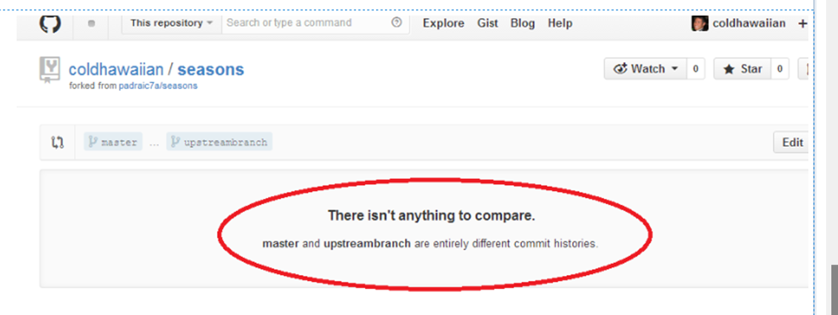

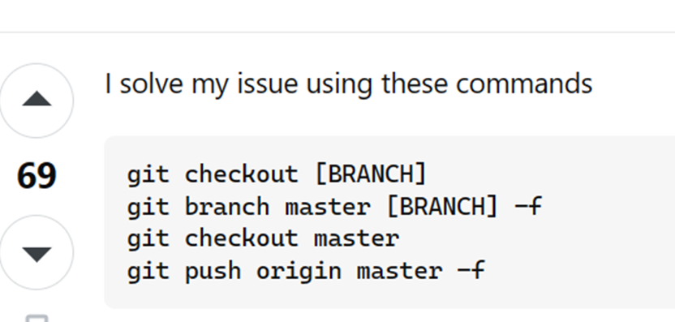

git checkout master   
git branch main master -f   
git checkout main   
git push origin main -f